**Unit 3 AP Computer Science A Practice Exam**

**Boolean Expressions and *if* Statements**

Section I – Multiple Choice

Optional Time – 20 minutes

15 Questions

1. Determine the output of the following code:

1. true
2. false
3. Nothing would output
4. An error would occur
5. Determine the output of the following code:

1. true
2. false
3. Nothing would output
4. An error would occur
5. According to DeMorgan’s laws, which of the following statements are equivalent to the one below?

*boolean a = !(x<3 && y>2);*

1. *boolean a = !(x<3) && !(y>2);*
2. *boolean a = !(x<3) || !(y>2);*
3. *boolean a = (x>=3 || y<=2);*
4. I only
5. II only
6. I and II
7. II and III
8. I, II, and III
9. The ==, !=, >, <, >=, and <= operators are?
10. Arithmetic Operators
11. Compound Assignment Operators
12. Relational Operators
13. Conditional Operators
14. Which of the following are true about conditional statements?
15. Conditional statements interrupt the sequential execution of statements.
16. The code inside of an *if* statement may not always run in a program, so essential, configuring code usually will be outside of one.
17. *if* statements affect the flow of control by executing different statements based on the value of a boolean expression.
18. I only
19. II only
20. I and II
21. II and III
22. I, II, and III
23. In order for there to be output from the code below, what would the value of “?” need to be?

1. 7
2. 26
3. 53
4. 77
5. Which of the following is FALSE about the following code?

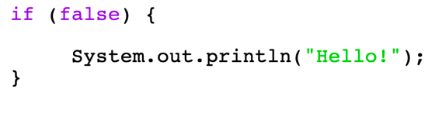

1. In its current state, the code will produce an error.
2. In its current state, the code will never produce any output.
3. If an else statement was added, the code inside of that will always run in the if statement’s current state.
4. I only
5. II only
6. I and II
7. II and III
8. What is the value of the variable *grade* after the code is run below, if the variable *score* is initialized to the value of *86*?

1. “B”
2. “C”
3. “D”
4. “F”
5. Which of the following are true about the concept of short circuit evaluation?
6. If the first condition of an && is false, the second condition is not necessarily checked.
7. If the first condition of an | | is true, the second condition is not necessarily checked.
8. If the first condition of an | | is false, the second condition is not necessarily checked.
9. I only
10. II only
11. I and II
12. I and III
13. II and III
14. Which of the following logical operators is NOT paired to its function?
15. *!* = *“Not”*, negates a value
16. *&&* = *“And”*, returns true if both expressions are true
17. *| |* = *“Or”*, returns true if one expression is true
18. None of the above
19. How many syntax errors are in the code shown below?

1. 1
2. 2
3. 3
4. 4
5. 5
6. Determine the output of the following code:

1. Hello
2. World
3. Hello

World

1. Nothing will be printed.
2. Which of the following is equivalent to the following code segment?

1. *x = 8;*
2. *if (x > 3) x *= 4;*
3. *if (x > 3) x = 8;*
4. *if (x > 3) x=8; else x *= 4;*
5. Determine the output of the following code:

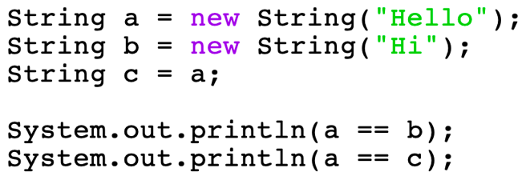

1. true

true

1. true

false

1. false

true

1. false

false

1. What program best represents the control flow diagram below?

1. A screenshot of a cell phone

   Description automatically generated

1. A screenshot of a cell phone

   Description automatically generated
2. None of the above

**END OF SECTION I**

Section II – Free Response Section

Optional Time – 15 minutes

2 Questions

1. Fill in the truth table according to the blanks already filled in below.

|  |  |  |  |  |
| --- | --- | --- | --- | --- |
| **A** | **B** | **!A** | **A && B** | **A | | B** |
| T | T |  |  |  |
| T | F |  |  |  |
| F | T |  |  |  |
| F | F |  |  |  |

1. Using the grading scale A: 90-100, B: 80-89, C: 70-79, D, 60-69, F: 0-59, write a program that takes in a double variable *myGrade* and prints out the letter grade earned. Use conditionals in your answer.

**END OF SECTION II**